**Demo 3**

**Solve Linear Problem Using Solver Add-in**



**Steps to be followed:**

**Step 1: Open the Excel file**

* 1. Open the file named **Solver-Add-in.xlsx**

**Step 2: Optimization problem**

**Problem statement**

An organization is preparing a bus trip for its 400 employees to Vegas. The admin team has contacted an agency that has ten 50 seater buses and eight 40 seater buses. However, only 9 drivers are available in a shift. The rental cost is $800 for a large bus and $600 for the smaller one. The admin team has to calculate the number of buses of each type that should be chartered at the least possible cost.

2.1 Check if the following data exists in the sheet

2.2 Calculate the minimum cost using Solver Add-in. Click on the **Data** tab, and click on **Solver** under the Analyze panel

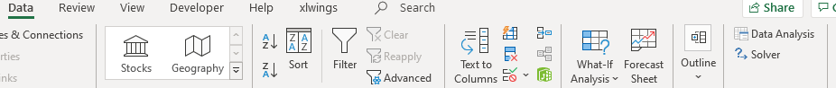

2.3 Set the options in the **Solver Add-in** as shown below:

The objective is F13 and the changing variables are C11:D11. The constraints are as typed. Select ‘GRG Nonlinear’ as the solving method.

2.4 Click on **Solve**

2.5 In the solver results dialog, click **OK**

2.6 The optimal solution is populated by Solver as shown below:

